

Submitted By:
Umair Umar CE-25-107
Assignment:
CA Lab No. 7
Submitted To:
Mr. Mehmood
For the fulfillment of,
Circuit Analysis Lab
Department of Computer Engineering
University of Engineering and Technology, Lahore

Circuit Analysis - Lab 7
Experiment 7: Analysis of Operational Amplifier Operations
Objective
To investigate the input-to-output relationship for inverting and non-inverting amplifier configurations using the IC 741 operational amplifier, and to verify the theoretical voltage gain in each case.

Results
Task 1 — Inverting Amplifier

Theoretical gain: Av = −R2 / R1 = −3 kΩ / 1 kΩ = −3
Expected output: Vout = Av × Vin = −3 × 2 V p-p = −6 V p-p (inverted, 180° phase shift)

Input Signal (CH A) | Output Signal — Inverting (CH B)
Sine wave — inverted and amplified  Amplitude: 1 V (peak)  Vp-p: 2 V  Frequency: 40 Hz  Phase: 0 degrees (reference) | Amplitude: 3 V (peak) Vp-p: 6 V Frequency: 40 Hz Phase: 180 degrees (inverted relative to input) Observation: The output waveform is flipped with respect to the input. When the input reaches its positive peak, the output is at its negative peak. Amplitude is 3x larger, confirming gain magnitude of 3.

Task 2 — Non-Inverting Amplifier
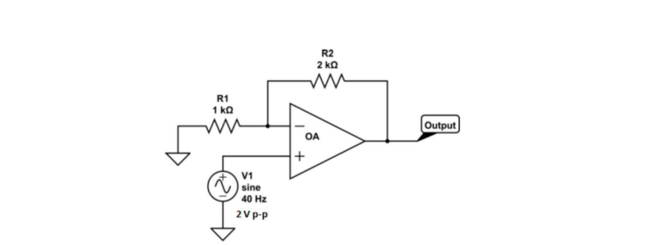
Theoretical gain: Av = 1 + R2 / R1 = 1 + 2 kΩ / 1 kΩ = +3
Expected output: Vout = Av × Vin = +3 × 2 V p-p = 6 V p-p (same phase as input)

Input Signal (CH A) | Output Signal — Non-Inverting (CH B)
Sine wave — amplified, same phase  Amplitude: 1 V (peak)  Vp-p: 2 V  Frequency: 40 Hz  Phase: 0 degrees (reference) | Amplitude: 3 V (peak) Vp-p: 6 V Frequency: 40 Hz Phase: 0 degrees (in phase with input) Observation: The output waveform has the same orientation as the input. Both positive peaks align in time. Amplitude is again 3x larger, confirming gain of +3. No phase inversion occurs.

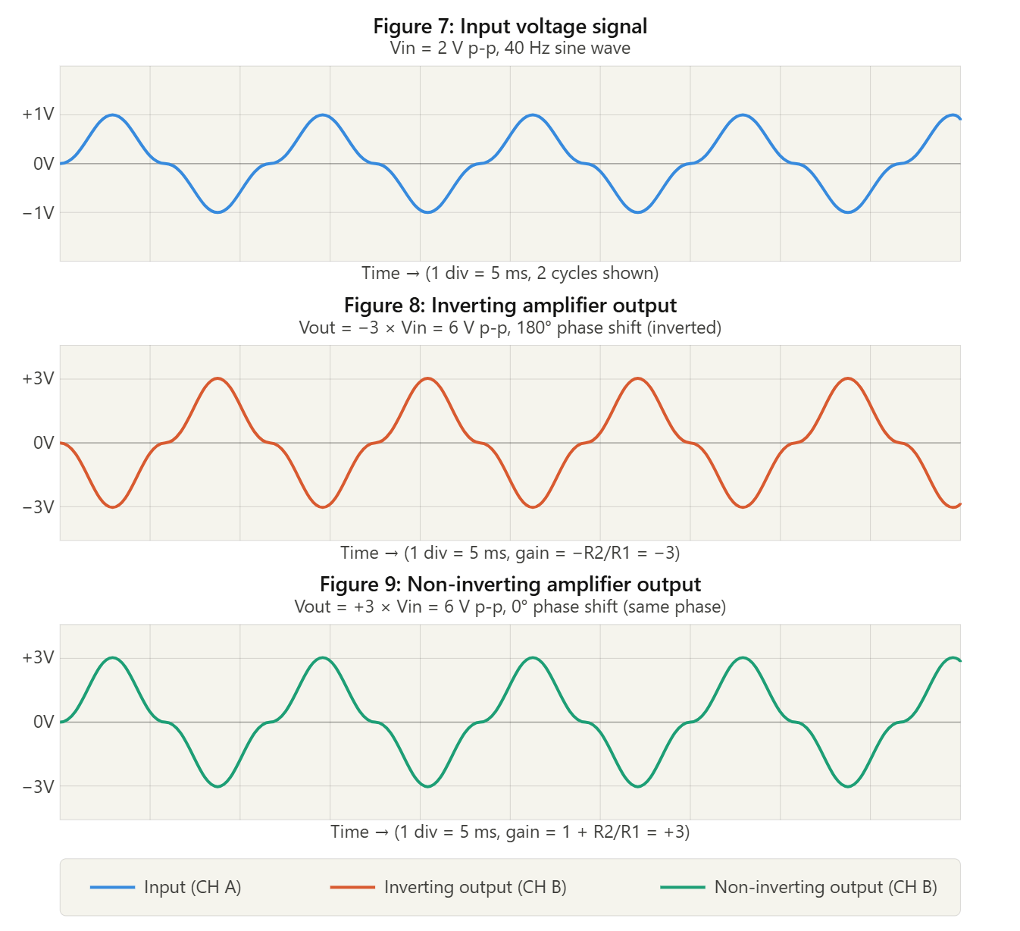
Summary: Gain Comparison
Parameter | Inverting Amp | Non-Inverting Amp | Unit
Gain Formula | −R2 / R1 | 1 + R2 / R1 | —
Resistor Values | R1=1kΩ, R2=3kΩ | R1=1kΩ, R2=2kΩ | —
Calculated Gain | −3 | +3 | —
Input Voltage | 2 | 2 | V p-p
Output Voltage (theory) | 6 | 6 | V p-p
Phase Shift | 180° | 0° | degrees

Post Lab Questions
Q1. Define inverting amplifier.
An inverting amplifier is an op-amp configuration in which the input signal is applied to the inverting terminal (pin 2, marked −) of the op-amp through an input resistor R1, while the non-inverting terminal (pin 3, marked +) is connected to ground. A feedback resistor R2 is connected between the output and the inverting terminal. The output signal is amplified and phase-shifted by exactly 180° relative to the input — that is, the output is an inverted (flipped) version of the input. The voltage gain is given by:
Av = −R2 / R1
The negative sign confirms the inversion. For R1 = 1 kΩ and R2 = 3 kΩ, Av = −3.

Q2. Define non-inverting amplifier.
A non-inverting amplifier is an op-amp configuration in which the input signal is applied directly to the non-inverting terminal (pin 3, marked +) of the op-amp. A voltage divider formed by R1 (connected from the inverting terminal to ground) and R2 (the feedback resistor from output to inverting terminal) sets the gain. The output signal is in phase with the input (0° phase shift) and is amplified by a positive gain factor. The voltage gain is given by:
Av = 1 + R2 / R1
The gain is always greater than or equal to 1. For R1 = 1 kΩ and R2 = 2 kΩ, Av = +3.

Q3. What are the applications of inverting amplifiers?
- Signal inversion: used wherever a 180° phase shift is needed in signal processing circuits.
- Summing amplifier: the inverting configuration can be extended to add multiple input voltages weighted by different resistors (virtual ground at inverting terminal allows superposition).
- Integrator circuits: by replacing R2 with a capacitor, the inverting op-amp becomes an integrator used in waveform generation and control systems.
- Active filters: inverting amplifiers form the basis of low-pass, high-pass, and band-pass active filter designs.
- Transresistance (I-to-V) converters: used in photodiode amplifiers where current input is converted to a voltage output.

Q4. What are the applications of non-inverting amplifiers?
- Voltage follower / buffer: when R2 = 0 and R1 = infinity, gain = 1. Used as a buffer between stages to prevent loading.
- Sensor signal amplification: non-inverting configuration is preferred when the input signal must not be phase-inverted, such as amplifying outputs from thermocouples or pressure sensors.
- Instrumentation amplifiers: non-inverting stages form the input stage of instrumentation amplifiers used in medical and measurement equipment.
- Audio preamplifiers: used to boost weak audio signals while maintaining phase coherence.
- Reference voltage amplifiers: for scaling reference voltages in ADC/DAC circuits without inversion.

Q5. What is gain of an amplifier?
The gain of an amplifier is defined as the ratio of the output signal magnitude to the input signal magnitude. It is a dimensionless quantity that tells us how much the amplifier multiplies the input. For op-amp circuits, gain can be expressed in terms of voltage:
Av = Vout / Vin
Gain can also be expressed in decibels (dB) using: Av(dB) = 20 × log10(|Av|). A gain greater than 1 means amplification. A gain less than 1 means attenuation. In the inverting amplifier, the gain is negative (indicating phase inversion) but its magnitude is still the amplification factor. For example, a gain of −3 means the output is 3 times larger in amplitude and phase-inverted.

Q6. How do you calculate the gains for inverting and non-inverting amplifiers?
Inverting Amplifier Gain
Using the virtual short and virtual open principles of an ideal op-amp, the inverting terminal is at virtual ground (0 V). Applying Kirchhoff's current law (KCL) at the inverting terminal:
Iin = Vin / R1 and If = −Vout / R2
Since Iin = If: Vin / R1 = −Vout / R2
Therefore: Av = Vout / Vin = −R2 / R1
For this experiment: Av = −3 kΩ / 1 kΩ = −3

Non-Inverting Amplifier Gain
The input is connected directly to the non-inverting terminal. The feedback network (R1 and R2) forms a voltage divider from the output back to the inverting terminal. Since both terminals are at the same potential (virtual short):
V− = Vout × R1 / (R1 + R2) = Vin
Solving: Av = Vout / Vin = 1 + R2 / R1
For this experiment: Av = 1 + 2 kΩ / 1 kΩ = +3

